1. 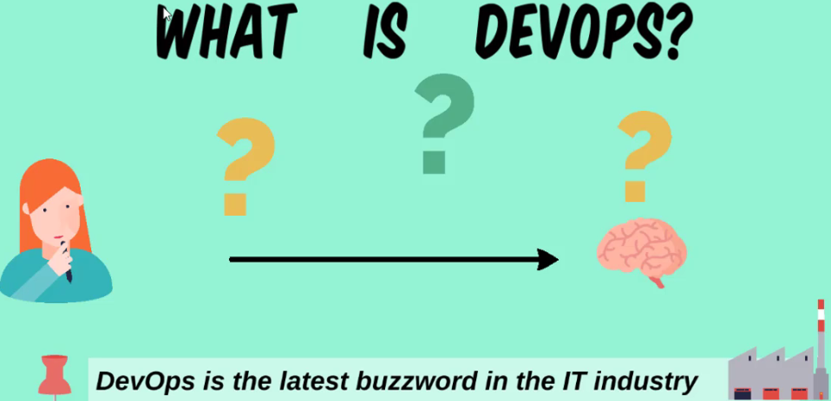
2. What is DevOps?
3. Is it software, tool or some framework?
4. It’s basically a culture.
5. Date back, there were some methodologies but those were not as efficient as DevOps.
6. Basically, DevOps bridges the gap b/w Developer and IT Operation.
7. It’s not like Developers would do IT Operations and IT team would do Developers’ operations.
8. When we say bridge, it means to achieve a goal efficiently on time without failure and with fewer resources.
9. When we say less resources, time-bound, quality, we’re putting here all the parameters.  
   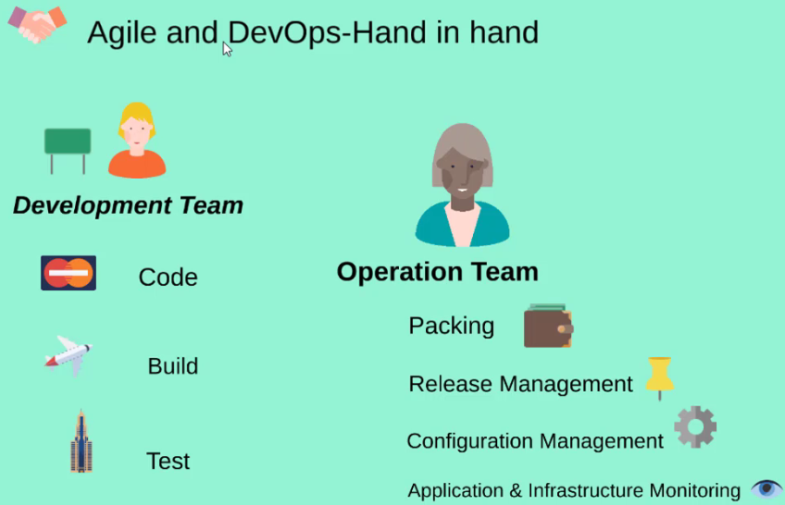
10. DevOps is the best model to achieve the common goal.
11. The Developers and Operation Team collaborate in such a way that their goal is common goal. It’s not like that developers and operation IT have different goal.
12. What are the responsibility of Development Team and Operation Team?
    1. They are well collaborative.
    2. There are notifications/messaging b/w them so they will communicate.